# EXPLORING ENGLISH TEACHERS’ EXPERIENCES IN TEACHING DURING COVID-19 PANDEMIC

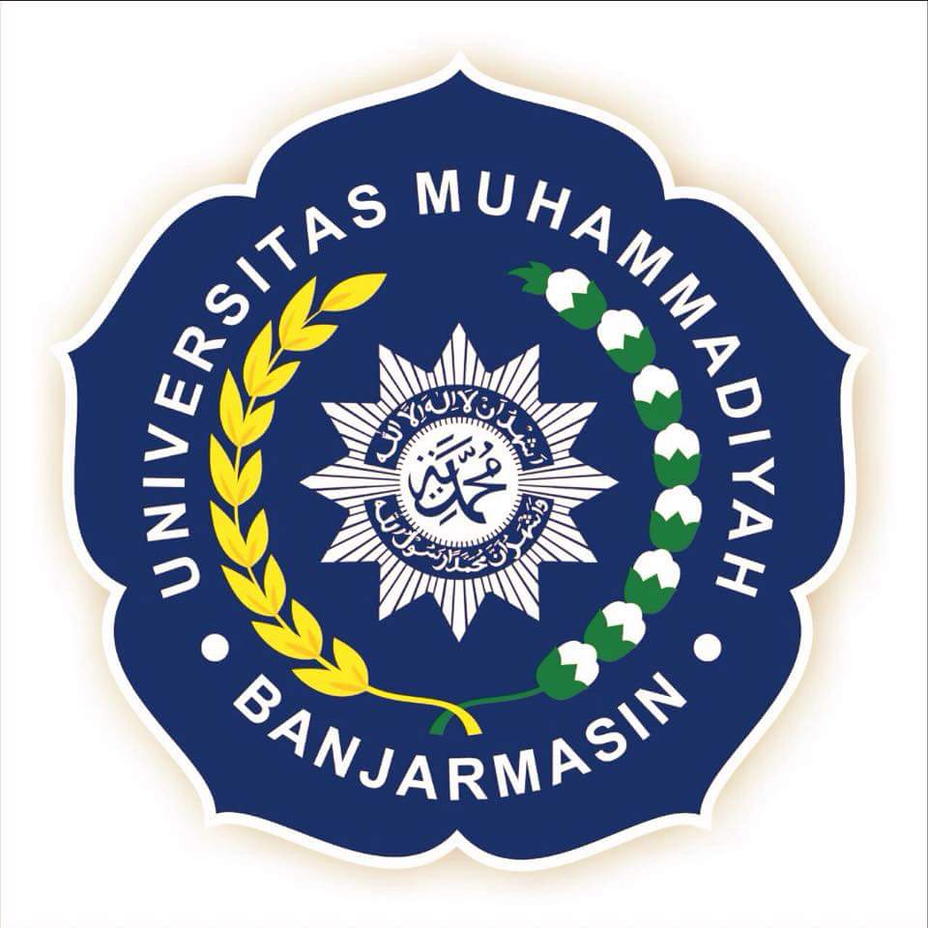

THESIS

Submitted as a Partial Fulfillment on the Requirements

For Getting Bachelor Degree of Education

in English Department

Written by:

Melly Thania 1788203110007

**ENGLISH LANGUAGE EDUCATION STUDY PROGRAM**

**FACULTY OF TEACHER TRAINING AND EDUCATION**

**UNIVERSITY OF MUHAMMADIYAH BANJARMASIN**

**BANJARMASIN**

**2021**